National College of Computer Studies
(NCCS-College of IT & Management)
Final Examination (2013)
Full Marks: 60
Pass Marks: 30
Time: 3 hour

Set: A
BSc.CSIT/ Third Semester/ CSC – 204 : Numerical Method

Attempt all questions.
- Derive the formula for Secant Method. Find a real root of following equation using bisection method correct up to four decimal places. [4+4]
- Derive the equation for Lagrange’s interpolating polynomial and find the missing value of f(x). [4+4]
X | 1 | 2 | 4 | 5 | 6
F(x) | 14 | 15 | 5 | ……. | 9
- Solve the following system of linear equations using Gauss Elimination method. [8]
x + 2y + 3z = 6
2x + 3y + 5z = 10
2x – y + 3z = 4
- Derive the expression for simpson 1/3 rule. Compute the Integral using Gaussian three point formula. [4+4]
I= dx
- Write the algorithm and program to solve the set of linear equation using Gauss Jordan method. [4+8]
- Solve the following differential equation using Heuns Method for y(0.2) take h=0.1
y(0)=1, y’(0)=0 [8]
- Solve the elliptic equation, for the following square mesh with boundary condition as shown in figure below: [8]
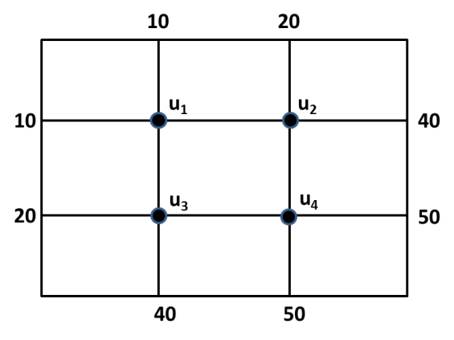
National College of Computer Studies
(NCCS-College of IT & Management)
Final Examination (2013)
Full Marks: 60
Pass Marks: 30
Time: 3 hour

Set: B
BSc.CSIT/ Third Semester/ CSC – 204 : Numerical Method

Attempt all questions.
- What are the different types of errors? Find a real root of following equation using Newton Raphson Method correct up to six decimal places. [4+4]
- What are the conditions for Cubic spline Interpolation. The temperature of a metal strip was measured at
various time intervals during heating and the values are given in the table below. Estimate the temperature
at t=6. [3+5]
Time, t (min) | 1 | 2 | 3 | 4
Temp, t(c) | 70 | 83 | 100 | 124
- Solve the following system of linear equations using Gauss Jordan method. [8]
x + 2y + 3z = 6
2x + 3y + 5z = 10
2x – y + 3z = 4
- Derive the expression for Trapezoidal rule. Compute the Integral using simpson 3/8 rule with n=4 [4+4]
I= dx
- Write the algorithm and program to solve the set of linear equation using Gauss Elimination method. [4+8]
- Solve the ordinary differential equation, for x = 0.6 with initial condition y(0) = 1, (0) = 0 by using R K fourth order method. (Take h = 0.3) [8]
- Solve the Poisson equation over the square domain 0 ≤ y ≤ 3 with h = k = 1 and boundary conditions are u(0,0) = 0, u(3,0) = 0, u(0,3) = 0 and u(3,3) = 0. [8]
